portfoliO

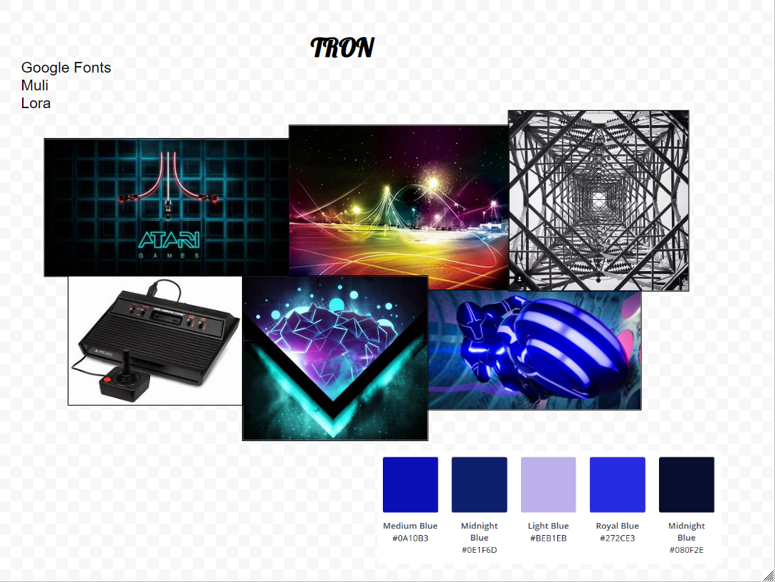

Contents

Design Brief……………………………………………………………………………………………………………………….2

Research………………………………………………………………………………………………………………………….3

Design Sketches………………………………………………………………………………………………………………....4

Design Changes…………………………………………………………………………………………………………………5

Evaluation…………………………………………………………………………………………………………………………6

# Design Brief

## Research

# dESIGN sketches

# DESIGN CHANGES

# evaluation